1. Implement Recursive Binary search and Linear search and determine the time required to search an element. Repeat the experiment for different values of n, the number of elements in the list to be searched and plot a gragh of the time taken versus n.

ALGORITHM : bin_srch(a[0….n-1],key)
//Implements recursive binary search
//Input: An array a[0….n-1] sorted in ascending order
// key- element to be searched
//Output: position of the array’s element that is equal to key is returned otherwise -1 is returned.
low ←0; high←n-1
if low>high
return -1
end if
mid←(low+high)/2
if key = a[mid]
return mid
end if
if key < a[mid]
high←mid-1
else
low←mid+1
end if

ALGORITHM : lin_srch(a[0….n-1],key)
//Implements sequential search with a search key as a sentinel
//Input: An array a[0….n-1] sorted in ascending order
// key- element to be searched
//Output: position of the first element in a[0….n-1] whose value is equal to key is returned otherwise -1 is
// returned.
i←0; high←n-1
if i>high
return -1
end if
if key = a[i]
return i
else
return lin_search(a,i+1,high,key)
end if

PROGRAM:
#include<stdio.h>
#include<conio.h>
#include<process.h>
int bin_srch(int[],int,int,int);
int lin_srch(int[],int,int,int);
void main()
{
int a[10],i,n,ans,key,ch;
clrscr();
while(1)
{
printf("\n\n1>binary search\t2>linear search\t3>exit\n");
printf("\nenter your choice:\t");
scanf("%d",&ch);
switch(ch)
{
case 1:printf("\nenter the no. of elements:\t");
scanf("%d",&n);
printf("\nenter the elements in ascending order:\n");
for(i=0;i<=n-1;i++)
{
scanf("%d",&a[i]);
}
printf("\nenter the key:\t");
scanf("%d",&key);
ans=bin_srch(a,0,n-1,key);
if(ans==-1)
{
printf("\nkey not found");
}
else
{
printf("\nkey found at position=%d",ans+1);
}
break;
case 2:printf("\nenter the no. of elements:\t");
scanf("%d",&n);
printf("\nenter the elements:\n");
for(i=0;i<=n-1;i++)
{
scanf("%d",&a[i]);
}
printf("\nenter the key:\t");
scanf("%d",&key);
ans=lin_srch(a,0,n-1,key);
if(ans==-1)
{
printf("\nkey not found");
}
else
{
printf("\nkey found at position=%d",ans+1);
}
break;
default:exit(0);
break;
}
getch();
}
}

int bin_srch(int a[],int low,int high,int key)
{
int mid;
if(low>high)
{
return -1;
}
mid=(low+high)/2;
if(key==a[mid])
{
return mid;
}
if(key<a[mid])
{
return bin_srch(a,low,mid-1,key);
}
else
{
return bin_srch(a,mid+1,high,key);
}
}

int lin_srch(int a[],int i,int high,int key)
{
if(i>high)
{
return -1;
}
if(key==a[i])
{
return i;
}
else
{
return lin_srch(a,i+1,high,key);
}
}

==========Output=============

1>binary search 2>linear search 3>exit

Enter your choice: 1

Enter the no. of elements: 4

Enter the elements in ascending order:
10 20 30 40

Enter the key: 30

Key found at position=3

1>binary search 2>linear search 3>exit

Enter your choice: 1

Enter the no. of elements: 4

Enter the elements in ascending order:
10 20 30 40

Enter the key: 50

Key not found

1>binary search 2>linear search 3>exit

Enter your choice: 2

Enter the no. of elements: 4

Enter the elements:
10 20 30 40

Enter the key: 20
1>binary search 2>linear search 3>exit

Enter your choice: 2

Enter the no. of elements: 4

Enter the elements:
10 20 30 40

Enter the key: 5

Key not found

1>binary search 2>linear search 3>exit

Enter your choice: 3
<exits from output screen>

TIME COMPLEXITY PROGRAM FOR BINARY SEARCH AND LINEAR SEARCH:

#include<stdio.h>
#include<conio.h>
#include<time.h>
int bin_srch(int [],int,int,int);
int lin_srch(int [],int,int,int);
void bub_sort(int[],int);
int n,a[3000];
void main()
{
int i,ch,key;
clock_t end,start;
clrscr();
while(1)
{
printf("1>binary search\t2>linear search\t3>exit\n");
printf("\nenter your choice:\t");
scanf("%d",&ch);
switch(ch)
{
case 1:n=0;
while(n<=1000)
{
for(i=0;i<n;i++)
{
a[i]=rand();
}
start=clock();
for(i=0;i<1000;i++)
{
bub_sort(a,n);
bin_srch(a,0,n-1,key);
}
end=clock();
printf("Time for n=%d is %f\n",n,(end-start)/CLK_TCK);
n=n+100;
}
break;
case 2:n=0;
while(n<=3000)
{
for(i=0;i<n;i++)
{
a[i]=rand();
}
start=clock();
for(i=0;i<20000;i++)
{
lin_srch(a,0,n-1,key);
}
end=clock();
printf("time for n=%d is %f\n",n,(end-start)/CLK_TCK);
n=n+300;
}
break;
default:exit(0);
}
getch();
}
}

int bin_srch(int a[],int low,int high,int key)
{
int mid;
if(low>high)
{
return -1;
}
mid=(low+high)/2;
if(key==a[mid])
{
return mid;
}
if(key<a[mid])
{
return bin_srch(a,low,mid-1,key);
}
else
{
return bin_srch(a,mid+1,high,key);
}
}

void bub_sort(int a[],int n)
{
int i,j,temp;
for(i=0;i<=n-2;i++)
{
for(j=0;j<=n-2-i;j++)
{
if(a[j]>a[j+1])
{
temp=a[j];
a[j]=a[j+1];
a[j+1]=temp;
}
}
}
}

int lin_srch(int a[],int i,int high,int key)
{
if(i>high)
{
return -1;
}
if(key==a[i])
{
return i;
}
else
{
return lin_srch(a,i+1,high,key);
}
}

==========Output============

1>binary search 2>linear search 3>exit

Enter your choice: 1

Time for n=0 is 0.000000
Time for n=100 is 0.000000
Time for n=200 is 0.054945
Time for n=300 is 0.164835
Time for n=400 is 0.274725
Time for n=500 is 0.439560
Time for n=600 is 0.549451
Time for n=700 is 0.824176
Time for n=800 is 1.043956
Time for n=900 is 1.318681
Time for n=1000 is 1.648352

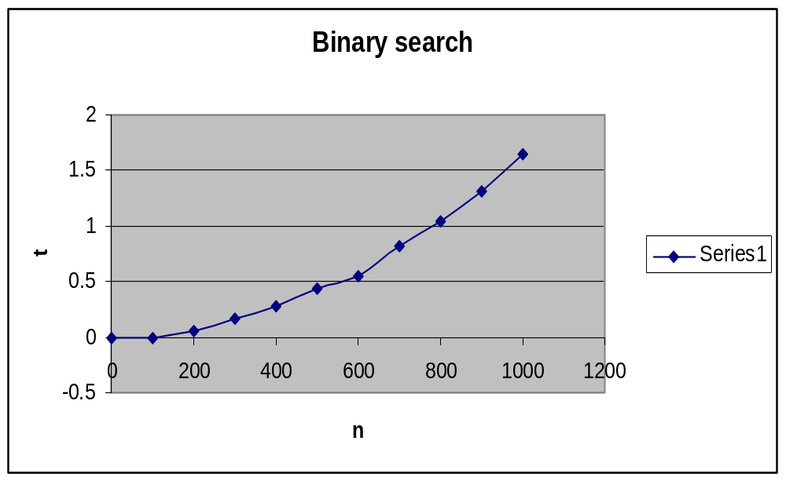

1> binary search 2>linear search 3>exit

Enter your choice: 2

Time for n=0 is 0.000000
Time for n=300 is 0.109890
Time for n=600 is 0.164835
Time for n=900 is 0.219780
Time for n=1200 is 0.329670
Time for n=1500 is 0.439560
Time for n=1800 is 0.494505
Time for n=2100 is 0.549451
Time for n=2400 is 0.659341
Time for n=2700 is 0.769231
Time for n=3000 is 0.769231
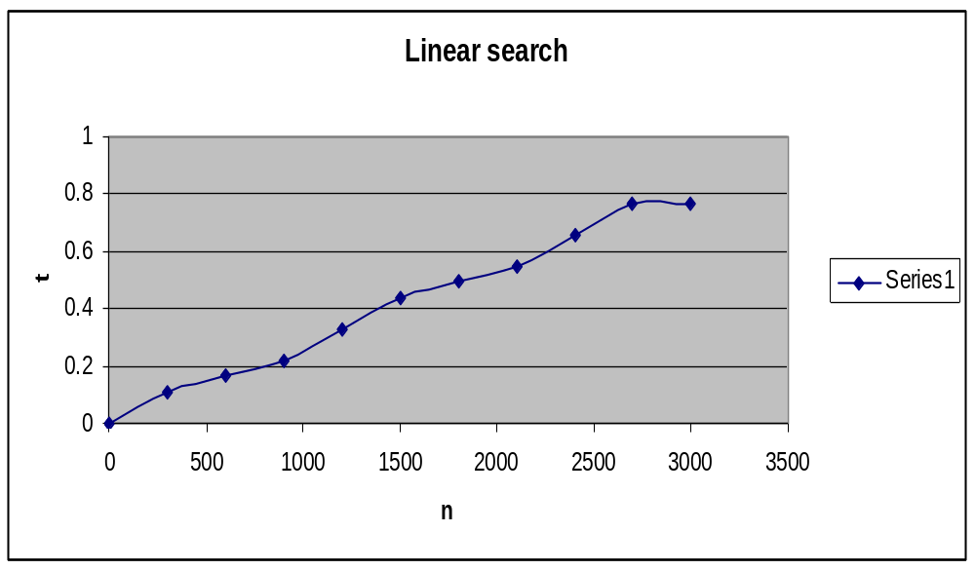

1> binary search 2>linear search 3>exit

Enter your choice: 3
<Exits from output screen>
======================
2.Sort a given set of elements using the Heap sort method and determine the time required to search an element. Repeat the experiment for different values of n, the number of elements in the list to be searched and plot a graph of the time taken versus n.

ALGORITHM : build_heap(a[0….n-1])
// constructs a max heap from the elements in the given array
// Input : An array a[0….n-1] of orderable elements
//Output : a[0….n-1] contains a max heap
for i←(n-1)/2 downto 0 do
heapify(a,n,p)
end for

ALGORITHM : heapify(a[0….n-1],p)
//create a heap for a subtree whose root node is identified as parent node p
//Input : An array a[0….n-1] of orderable elements
//Output : The subtree whose root node was identified as parent node p will be in a heap
item←a[p]
c←2*p+1
while c<=n-1 do
if c+1<=n-1
if a[c]<a[c+1]
c←c+1
end if
end if
if item<a[c]
a[p]←a[c]
p←c
c←2*p+1
else
break
end if
end while
a[p]←item

ALGORITHM : heap_sort(a[0….n-1])
// To sort the items by using heap
//Input : The items of array a[0….n-1] to be sorted
//Output : a[0…n-1] contains sorted items
for i←n-1 downto 0 do
swap a[0] and a[i]
build_heap(a,i)
end for

PROGRAM :
#include<stdio.h>
#include<conio.h>
void build_heap(int[],int);
void heapify(int[],int,int);
void heap_sort(int[],int);
void main()
{
int a[10],i,n;
clrscr();
printf("\nenter the no. of elements:\t");
scanf("%d",&n);
printf("\nenter the elements:\n");
for(i=0;i<=n-1;i++)
{
scanf("%d",&a[i]);
}
build_heap(a,n);
heap_sort(a,n);
printf("\nthe sorted array is:\n");
for(i=0;i<=n-1;i++)
{
printf("%d\t",a[i]);
}
getch();
}
void build_heap(int a[],int n)
{
int p;
for(p=(n-1)/2;p>=0;p--)
{
heapify(a,n,p);
}
}

void heapify(int a[],int n,int p)
{
int item,c;
item=a[p];
c=2*p+1;
while(c<=n-1)
{
if(c+1<=n-1)
{
if(a[c]<a[c+1])
{
c=c+1;
}
}
if(item<a[c])
{
a[p]=a[c];
p=c;
c=2*p+1;
}
else
{
break;
}
}
a[p]=item;
}

void heap_sort(int a[],int n)
{
int i,temp;
for(i=n-1;i>0;i--)
{
temp=a[0];
a[0]=a[i];
a[i]=temp;
build_heap(a,i);
}
}
==========Output============
Enter the no. of elements: 8

Enter the elements:
55 33 11 99 88 22 44 77

The sorted array is:
11 22 33 44 55 77 88 99
=====================

TIME COMPLEXITY PROGRAM FOR HEAP SORT:

#include<stdio.h>
#include<conio.h>
#include<time.h>
void build_heap(int[],int);
void heapify(int[],int,int);
void heap_sort(int[],int);
void main()
{
int a[16000],i;
long int n=500;
clock_t start,end;
clrscr();
while(n<=16000)
{
for(i=0;i<=n-1;i++)
{
a[i]=rand();
}
start=clock();
build_heap(a,n);
heap_sort(a,n);
end=clock();
printf("\nthe time taken for n=%lu is %f\n",n,(end-start)/CLK_TCK);
n=n+1000;
}
getch();
}

void build_heap(int a[],int n)
{
int p;
for(p=(n-1)/2;p>=0;p--)
{
heapify(a,n,p);
}
}

void heapify(int a[],int n,int p)
{
int item,c;
item=a[p];
c=2*p+1;
while(c<=n-1)
{
if(c+1<=n-1)
{
if(a[c]<a[c+1])
{
c=c+1;
}
}
if(item<a[c])
{
a[p]=a[c];
p=c;
c=2*p+1;
}
else
{
break;
}
}
a[p]=item;
}

void heap_sort(int a[],int n)
{
int i,temp;
for(i=n-1;i>0;i--)
{
temp=a[0];
a[0]=a[i];
a[i]=temp;
build_heap(a,i);
}
}
==========Output============
The time taken for n=500 is 0.000000
The time taken for n=1500 is 0.054945
The time taken for n=2500 is 0.164835
The time taken for n=3500 is 0.274725
The time taken for n=4500 is 0.439560
The time taken for n=5500 is 0.714286
The time taken for n=6500 is 0.989011
The time taken for n=7500 is 1.263736
The time taken for n=8500 is 1.593407
The time taken for n=9500 is 2.032967
The time taken for n=10500 is 2.472527
The time taken for n=11500 is 2.967033
The time taken for n=12500 is 3.516484
The time taken for n=13500 is 4.120879
The time taken for n=14500 is 4.725275
The time taken for n=15500 is 5.439560
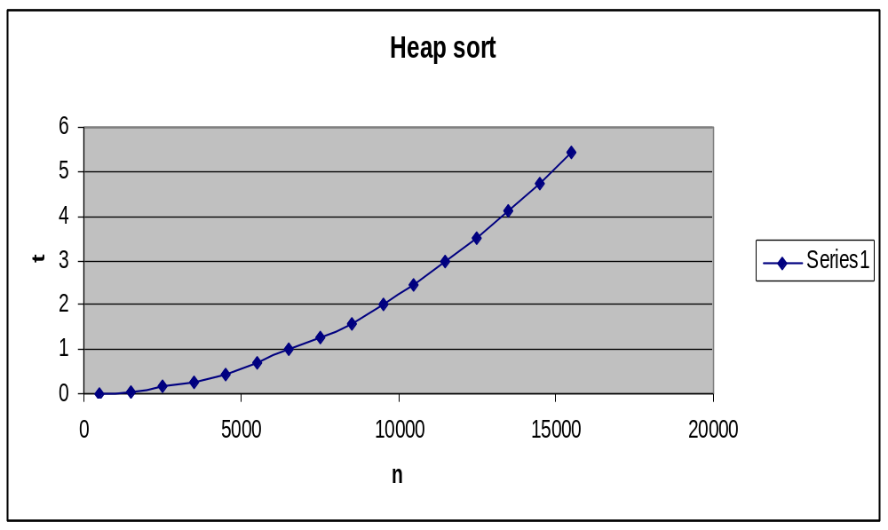
======================
3. Sort a given set of elements using the Merge sort method and determine the time required to search an element. Repeat the experiment for different values of n, the number of elements in the list to be searched and plot a graph of the time taken versus n.

ALGORITHM : combine(a[0….n-1],low,mid,high)
//merge two sorted arrays where first array starts from low to mid and second starts from mid+1 to high
//Input : a is a sorted array from index position low to mid
// a is a sorted array from index position mid+1 to high
//Output: Array a[0….n-1] sorted in nondecreasing order
i←low
j←mid+1
k←low
while i<=mid and j<=high do
if a[i]<a[j]
c[k]←a[i]
k←k+1
i←i+1
else
c[k]←a[j]
k←k+1
j←j+1
end if
end while
if i>mid
while j<=high do
c[k]←a[j]
k←k+1
j←j+1
end while
end if
if j>high
while i<=mid do
c[k]←a[i]
k←k+1
i←i+1
end while
end if
for i←low to high do
a[i]←c[i]
end for

ALGORITHM: split(a[0….n-1],low,high)
//Sorts array a[0….n-1] by recursive mergesort
//Input :An array a[0….n-1] of orderable elements
//Output : Array a[0….n-1] sorted in nondecreasing order
if low<high
mid←(low+high)/2
split(a,low,mid)
split(a,mid+1,high)
combine(a,low,mid,high)
end if

PROGRAM :
#include<stdio.h>
#include<conio.h>
#include<process.h>
void split(int[],int,int);
void combine(int[],int,int,int);
void main()
{
int a[20],i,n;
clrscr();
printf("\nenter the no. of elements:\t");
scanf("%d",&n);
printf("\nenter the elements:\n");
for(i=0;i<=n-1;i++)
{
scanf("%d",&a[i]);
}
split(a,0,n-1);
printf("\nthe sorted array is:\n");
for(i=0;i<=n-1;i++)
{
printf("%d\t",a[i]);
}
getch();
}

void split(int a[],int low,int high)
{
int mid;
if(low<high)
{
mid=(low+high)/2;
split(a,low,mid);
split(a,mid+1,high);
combine(a,low,mid,high);
}
}

void combine(int a[],int low,int mid,int high)
{
int c[20],i,j,k;
i=k=low;
j=mid+1;
while(i<=mid&&j<=high)
{
if(a[i]<a[j])
{
c[k]=a[i];
++k;
++i;
}
else
{
c[k]=a[j];
++k;
++j;
}
}
if(i>mid)
{
while(j<=high)
{
c[k]=a[j];
++k;
++j;
}
}
if(j>high)
{
while(i<=mid)
{
c[k]=a[i];
++k;
++i;
}
}
for(i=low;i<=high;i++)
{
a[i]=c[i];
}
}
==========Output=============
Enter the no. of elements: 8

Enter the elements:
55 33 11 99 88 22 44 77

The sorted array is:
11 22 33 44 55 77 88 99
=====================

TIME COMPLEXITY PROGRAM FOR MERGE SORT:

#include<stdio.h>
#include<conio.h>
#include<time.h>
void split(int[],int,int);
void combine(int[],int,int,int);
void main()
{
int a[15000],i,j;
long int n=500;
clock_t start,end;
clrscr();
while(n<=15000)
{
for(i=0;i<=n-1;i++)
{
a[i]=rand();
}
start=clock();
for(j=0;j<100;j++)
{
split(a,0,n-1);
}
end=clock();
printf("\nthe time taken for n=%lu is %f\n",n,(end-start)/CLK_TCK);
n=n+1000;
}
getch();
}

void split(int a[],int low,int high)
{
int mid;
if(low<high)
{
mid=(low+high)/2;
split(a,low,mid);
split(a,mid+1,high);
combine(a,low,mid,high);
}
}

void combine(int a[],int low,int mid,int high)
{
int c[15000],i,j,k;
i=k=low;
j=mid+1;
while(i<=mid&&j<=high)
{
if(a[i]<a[j])
{
c[k]=a[i];
++k;
++i;
}
else
{
c[k]=a[j];
++k;
++j;
}
}
if(i>mid)
{
while(j<=high)
{
c[k]=a[j];
++k;
++j;
}
}
if(j>high)
{
while(i<=mid)
{
c[k]=a[i];
++k;
++i;
}
}
for(i=low;i<=high;i++)
{
a[i]=c[i];
}
}
==========Output=============
the time taken for n=500 is 0.000000
the time taken for n=1500 is 0.000000
the time taken for n=2500 is 0.054945
the time taken for n=3500 is 0.054945
the time taken for n=4500 is 0.109890
the time taken for n=5500 is 0.109890
the time taken for n=6500 is 0.109890
the time taken for n=7500 is 0.109890
the time taken for n=8500 is 0.164835
the time taken for n=9500 is 0.219780
the time taken for n=10500 is 0.219780
the time taken for n=11500 is 0.219780
the time taken for n=12500 is 0.219780
the time taken for n=13500 is 0.274725
the time taken for n=14500 is 0.274725
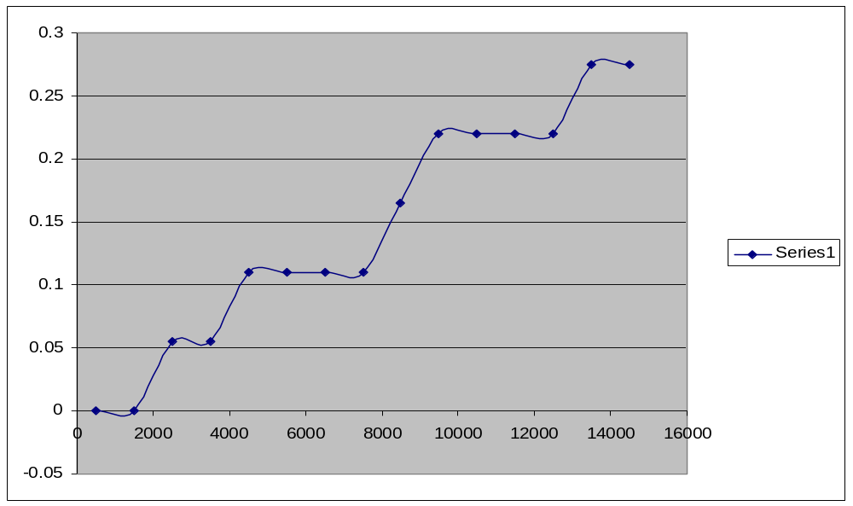

=====================

4. Sort a given set of elements using the Selection sort method and determine the time required to search an element. Repeat the experiment for different values of n, the number of elements in the list to be searched and plot a graph of the time taken versus n.

ALGORITHM : sel_sort(a[0….n-1]
//Sorts a given array by selection sort
//Input : An array a[0….n-1] of orderable elements
//Output : Array a[0….n-1] sorted in ascending order
for i←0 to n-2 do
small_pos←i
for j←i+1 to n-1 do
if a[j]<a[small_pos]
small_pos←j
end if
end for
swap a[i] and a[small_pos]
end for

PROGRAM :
#include<stdio.h>
#include<conio.h>
void sel_sort(int[],int);
void main()
{
int a[20],i,n;
clrscr();
printf("\nenter the no. of elements:\t");
scanf("%d",&n);
printf("\nenter the elements:\n");
for(i=0;i<=n-1;i++)
{
scanf("%d",&a[i]);
}
sel_sort(a,n);
printf("\nthe sorted array is:\n");
for(i=0;i<=n-1;i++)
{
printf("%d\t",a[i]);
}
getch();
}

void sel_sort(int a[],int n)
{
int i,j,small_pos,temp;
for(i=0;i<=n-2;i++)
{
small_pos=i;
for(j=i+1;j<=n-1;j++)
{
if(a[j]<a[small_pos])
{
small_pos=j;
}
}
temp=a[i];
a[i]=a[small_pos];
a[small_pos]=temp;
}
}
==========Output=============
Enter the no. of elements: 8

Enter the elements:
55 33 11 99 88 22 44 77

The sorted array is:
11 22 33 44 55 77 88 99
=====================

TIME COMPLEXITY PROGRAM FOR SELECTION SORT:

#include<stdio.h>
#include<conio.h>
#include<time.h>
void sel_sort(int[],int);
void main()
{
int i;
clock_t start,end;
long int n=500;
int a[20000];
clrscr();
while(n<=20000)
{
for(i=0;i<=n-1;i++)
{
a[i]=rand();
}
start=clock();
sel_sort(a,n);
end=clock();
printf("\nthe time taken for n=%lu is %f\n",n,(end-start)/CLK_TCK);
n=n+1000;
}
getch();
}

void sel_sort(int a[],int n)
{
int i,j,small_pos,temp;
for(i=0;i<=n-2;i++)
{
small_pos=i;
for(j=i+1;j<=n-1;j++)
{
if(a[j]<a[small_pos])
{
small_pos=j;
}
}
temp=a[i];
a[i]=a[small_pos];
a[small_pos]=temp;
}
}
==========Output=============
the time taken for n=500 is 0.000000
the time taken for n=1500 is 0.000000
the time taken for n=2500 is 0.000000
the time taken for n=3500 is 0.000000
the time taken for n=4500 is 0.054945
the time taken for n=5500 is 0.054945
the time taken for n=6500 is 0.054945
the time taken for n=7500 is 0.054945
the time taken for n=8500 is 0.109890
the time taken for n=9500 is 0.109890
the time taken for n=10500 is 0.164835
the time taken for n=11500 is 0.164835
the time taken for n=12500 is 0.219780
the time taken for n=13500 is 0.274725
the time taken for n=14500 is 0.274725
the time taken for n=15500 is 0.329670
the time taken for n=16500 is 0.329670

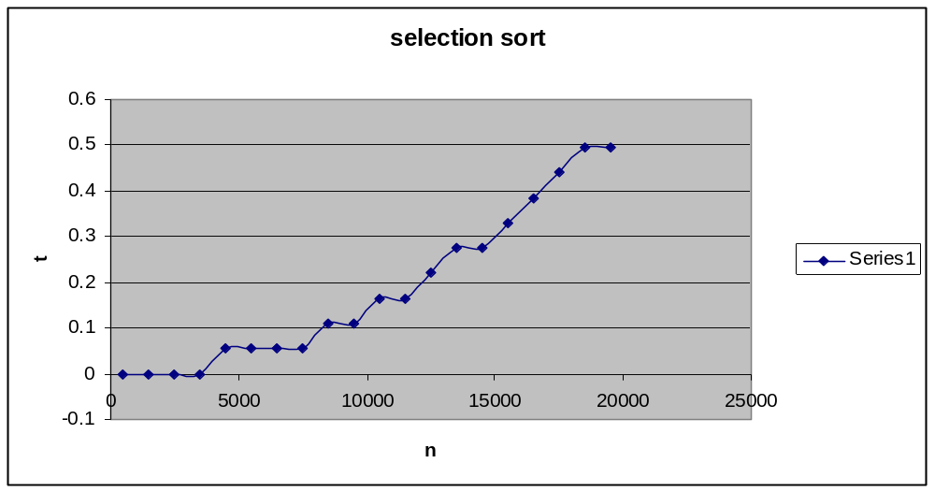

=====================

5.Implement 0/1 Knapsack problem using Dynamic programming.

ALGORITHM : knapsack(w[1…n],p[1…n],n,m)
//To find the optimal solution for the Knapsack problem using dynamic programming
// Input: n-number of objects to be selected
// m-maximum capacity of the Knapsack
// An array w[1….n] contains weights of all objects
// An array p[1….n] contains profits of all objects
// Output :A matrix v[0….n,0….m] contains the optimal solution for the number of objects selected with
// specified remaining capacity
for i←0 to n do
for j←0 to m do
if i=0 or j=0
v[i,j]=0
else if j-w[i]<0
v[i,j]=v[i-1,j]
else
v[i,j]=max(v[i-1,j],v[i-1,j-w[i]+p[i])
end if
end for
end for
write ‘the output is’
for i←0 to n do
for j←0 to m do
write v[i,j]
end for
end for
write ‘the optimal solution is’,v[n,m]
write ‘solution vector is’
for i←n downto 1 do
if v[i,m]!=v[i-1,m]
x[i]←1
m←m-w[i]
else
x[i]←0
end if
end for
for i←1 to n do
write x[i]
end for
return

PROGRAM:
#include<stdio.h>
#include<conio.h>
void knapsack();
int max(int,int);
int i,j,n,m,p[10],w[10],v[10][10];
void main()
{
clrscr();
printf("\nenter the no. of items:\t");
scanf("%d",&n);
printf("\nenter the weight of the each item:\n");
for(i=1;i<=n;i++)
{
scanf("%d",&w[i]);
}
printf("\nenter the profit of each item:\n");
for(i=1;i<=n;i++)
{
scanf("%d",&p[i]);
}
printf("\nenter the knapsack's capacity:\t");
scanf("%d",&m);
knapsack();
getch();
}

void knapsack()
{
int x[10];
for(i=0;i<=n;i++)
{
for(j=0;j<=m;j++)
{
if(i==0||j==0)
{
v[i][j]=0;
}
else if(j-w[i]<0)
{
v[i][j]=v[i-1][j];
}
else
{
v[i][j]=max(v[i-1][j],v[i-1][j-w[i]]+p[i]);
}
}
}
printf("\nthe output is:\n");
for(i=0;i<=n;i++)
{
for(j=0;j<=m;j++)
{
printf("%d\t",v[i][j]);
}
printf("\n\n");
}
printf("\nthe optimal solution is %d",v[n][m]);
printf("\nthe solution vector is:\n");
for(i=n;i>=1;i--)
{
if(v[i][m]!=v[i-1][m])
{
x[i]=1;
m=m-w[i];
}
else
{
x[i]=0;
}
}
for(i=1;i<=n;i++)
{
printf("%d\t",x[i]);
}
}

int max(int x,int y)
{
if(x>y)
{
return x;
}
else
{
return y;
}
}
==========Output=============
Enter the no. of items: 4

Enter the weight of each item:
2 1 3 2

Enter the profit of the each item:
12 10 20 15

Enter the Knapsack’s capacity: 5

The output is:
0 0 0 0 0 0
0 0 12 12 12 12
0 10 12 22 22 22
0 10 12 22 30 32
0 10 15 25 30 37

The optimal solution is: 37

The solution vector is:
1 1 0 1
=====================
6. From a given vertex in a weighted connected graph, find shortest paths to other vertices using Dijkstra’s algorithm.

ALGORITHM: dijkstras(c[1….n,1….n],src)
//To compute shortest distance from given source node to all nodes of a weighted undirected graph
//Input: An nXn cost matrix c[1…n,1….n] with source node src
//Output: The length dist[j] of a shortest path from src to j
for j←1 to n do
dist[j]←c[src,[j]
end for
for j←1 to n do
vis[j]←0
end for
dist[src]←0
vis[src]←1
count←1
while count!=n do
min←9999
for j←1 to n do
if dist[j]<min and vis[j]!=1
min←dist[j]
u←j
end if
end for
vis[u]←1
count←count+1
for j←1 to n do
if min+c[u,j]<dist[j] and vis[j]!=1
dist[j]←min+c[u,j]
end if
end for
end while
write ‘shortest distance is’
for j←1 to n do
write src,j,dist[j]
end for

PROGRAM:
#include<stdio.h>
#include<conio.h>
void dijkstras();
int c[10][10],n,src;
void main()
{
int i,j;
clrscr();
printf("\nenter the no of vertices:\t");
scanf("%d",&n);
printf("\nenter the cost matrix:\n");
for(i=1;i<=n;i++)
{
for(j=1;j<=n;j++)
{
scanf("%d",&c[i][j]);
}
}
printf("\nenter the source node:\t");
scanf("%d",&src);
dijkstras();
getch();
}

void dijkstras()
{
int vis[10],dist[10],u,j,count,min;
for(j=1;j<=n;j++)
{
dist[j]=c[src][j];
}
for(j=1;j<=n;j++)
{
vis[j]=0;
}
dist[src]=0;
vis[src]=1;
count=1;
while(count!=n)
{
min=9999;
for(j=1;j<=n;j++)
{
if(dist[j]<min&&vis[j]!=1)
{
min=dist[j];
u=j;
}
}
vis[u]=1;
count++;
for(j=1;j<=n;j++)
{
if(min+c[u][j]<dist[j]&&vis[j]!=1)
{
dist[j]=min+c[u][j];
}
}
}
printf("\nthe shortest distance is:\n");
for(j=1;j<=n;j++)
{
printf("\n%d----->%d=%d",src,j,dist[j]);
}
}
==========Output=============
Enter the no. of vertices: 5

Enter the cost matrix:
9999 3 9999 7 9999
3 9999 4 2 9999
9999 4 9999 5 6
7 2 5 9999 4
9999 9999 6 4 9999

Enter the source node: 1

The shortest distance is:
1-----------> 1 = 0
1-----------> 2 = 3
1-----------> 3 = 7
1-----------> 4 = 5
1-----------> 5 = 9
=====================

7. Sort a given set of elements using the Quick sort method and determine the time required to search an element. Repeat the experiment for different values of n, the number of elements in the list to be searched and plot a graph of the time taken versus n.

ALGORITHM: partition(a[0….n-1],low,high)
//partition the array into parts such that elements towards the left of the key element are
//less than key element and elements towards right of the key element are greater than key element
//Input: An array a[0….n-1] is unsorted from index position low to high
//Output: A partition of a[0…n-1] with split position returned as this function’s value
key←a[low]
i←low+1
j←high
while(1)
while a[i]<=key and i<=high do
i←i+1
end while
while a[j]>key and j>=low do
j←j-1
end while
if i<j
swap a[i] and a[j]
else
swap a[low] and a[j]
return j
end if
end while

ALGORITHM: quick_sort(a[0….n-1],low,high)
//Sorts the elements of the array between lower bound low and upper bound high
//Input: An array a[0….n-1] is unsorted from index position low to high
//Output: Array a[0….n-1] is sorted in nondecreasing order
if low<high
j←partition(a,low,high)
quick_sort(a,low,j-1)
quick_sort(a,j+1,high)
end if

PROGRAM:
#include<stdio.h>
#include<conio.h>
void quick_sort(int[],int,int);
int partition(int[],int,int);
void main()
{
int a[20],i,n;
clrscr();
printf("\nenter the no. of elements:\t");
scanf("%d",&n);
printf("\nenter the elements:\n");
for(i=0;i<=n-1;i++)
{
scanf("%d",&a[i]);
}
quick_sort(a,0,n-1);
printf("\nthe sorted array is:\n");
for(i=0;i<=n-1;i++)
{
printf("%d\t",a[i]);
}
getch();
}

void quick_sort(int a[],int low,int high)
{
int j;
if(low<high)
{
j=partition(a,low,high);
quick_sort(a,low,j-1);
quick_sort(a,j+1,high);
}
}

int partition(int a[],int low,int high)
{
int i,j,key,temp;
key=a[low];
i=low+1;
j=high;
while(1)
{
while(a[i]<key&&i<=high)
{
++i;
}
while(a[j]>key&&j>=low)
{
--j;
}
if(i<j)
{
temp=a[i];
a[i]=a[j];
a[j]=temp;
}
else
{
temp=a[low];
a[low]=a[j];
a[j]=temp;
return j;
}
}
}
==========Output=============
Enter the no. of elements: 8

Enter the elements:
55 33 11 99 88 22 44 77

The sorted array is:
11 22 33 44 55 77 88 99
=====================

TIME COMPLEXITY PROGRAM FOR QUICK SORT:

#include<stdio.h>
#include<conio.h>
#include<stdlib.h>
#include<time.h>
void quick_sort(int[],int,int);
int partition(int[],int,int);
void main()
{
int a[3500],i,j;
long int n=500;
clock_t start,end;
clrscr();
while(n<=3500)
{
for(i=0;i<n;i++)
{
a[i]=rand();
}
start=clock();
for(j=0;j<100;j++)
{
quick_sort(a,0,n-1);
}
end=clock();
printf("\nthe time taken for n=%lu is %f\n",n,(end-start)/CLK_TCK);
n=n+500;
}
getch();
}

void quick_sort(int a[],int low,int high)
{
int j;
if(low<high)
{
j=partition(a,low,high);
quick_sort(a,low,j-1);
quick_sort(a,j+1,high);
}
}

int partition(int a[],int low,int high)
{
int i,j,key,temp;
key=a[low];
i=low+1;
j=high;
while(1)
{
while(a[i]<=key&&i<=high)
{
++i;
}
while(a[j]>key&&j>=low)
{
--j;
}
if(i<j)
{
temp=a[i];
a[i]=a[j];
a[j]=temp;
}
else
{
temp=a[low];
a[low]=a[j];
a[j]=temp;
return j;
}
}
}

==========Output=============
the time taken for n= 500 is 0.000000
the time taken for n= 1000 is 0.109890
the time taken for n= 1500 is 0.219780
the time taken for n= 2000 is 0.439560
the time taken for n= 2500 is 0.604396
the time taken for n= 3000 is 0.879121
the time taken for n= 3500 is 1.208791
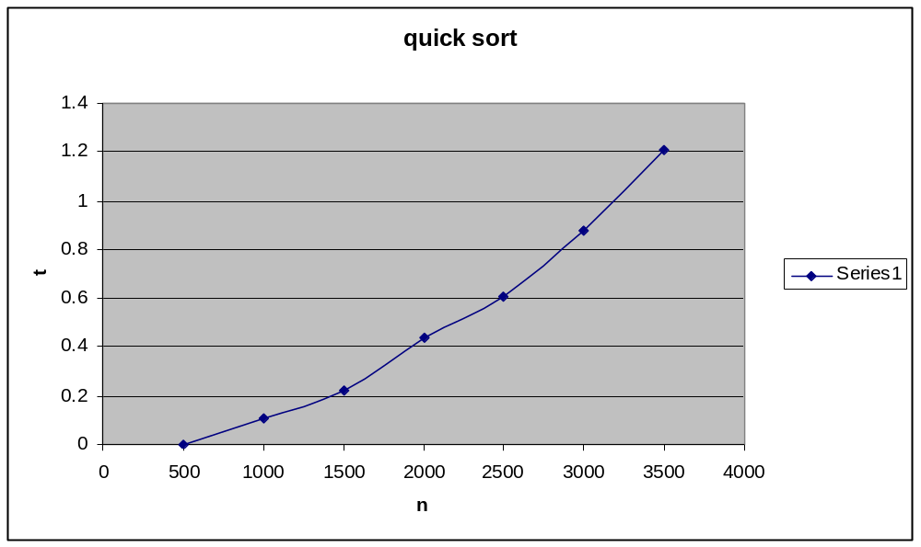

=====================
8.Find Minimum Cost Spanning Tree of a given undirected graph using Kruskal’s algorithm.

ALGORITHM: kruskals(c[1…n,1…n])
//To compute the minimum spanning tree of a given weighted undirected graph using Kruskal’s
// algorithm
//Input: An nXn cost matrix c[1…n,1….n]
//Output: minimum cost of spanning tree of given undirected graph
ne←0
mincost←0
for i←1 to n do
parent[i]←0
end for
while ne!=n-1 do
min←9999
for i←1 to n do
for j←1 to n do
if c[i,j]<min
min←c[i,j]
u←i
a←i
v←j
b←j
end if
end for
end for
while parent[u]!=0 do
u←parent[u]
end while
while parent[v]!=0 do
v←parent[v]
end while
if u!= v
write a,b,min
parent[v]←u
ne←ne+1
mincost←mincost+min
end if
c[a,b]←9999
c[b,a]←9999
end while
write mincost
return

PROGRAM:
#include<stdio.h>
#include<conio.h>
void kruskals();
int c[10][10],n;
void main()
{
int i,j;
clrscr();
printf("\nenter the no. of vertices:\t");
scanf("%d",&n);
printf("\nenter the cost matrix:\n");
for(i=1;i<=n;i++)
{
for(j=1;j<=n;j++)
{
scanf("%d",&c[i][j]);
}
}
kruskals();
getch();
}

void kruskals()
{
int i,j,u,v,a,b,min;
int ne=0,mincost=0;
int parent[10];
for(i=1;i<=n;i++)
{
parent[i]=0;
}
while(ne!=n-1)
{
min=9999;
for(i=1;i<=n;i++)
{
for(j=1;j<=n;j++)
{
if(c[i][j]<min)
{
min=c[i][j];
u=a=i;
v=b=j;
}
}
}
while(parent[u]!=0)
{
u=parent[u];
}
while(parent[v]!=0)
{
v=parent[v];
}
if(u!=v)
{
printf("\n%d----->%d=%d\n",a,b,min);
parent[v]=u;
ne=ne+1;
mincost=mincost+min;
}
c[a][b]=c[b][a]=9999;
}
printf("\nmincost=%d",mincost);
}
==========Output=============
Enter the no. of vertices: 6

Enter the cost matrix:
9999 3 9999 9999 6 5
3 9999 1 9999 9999 4
9999 1 9999 6 9999 4
9999 6 6 9999 8 5
6 9999 9999 8 9999 2
5 4 4 5 2 9999

2-----------> 3 = 1
5-----------> 6 = 2
1-----------> 2 = 3
2-----------> 6 = 4
4-----------> 6 = 5

Mincost = 15
=====================
9. a. Print all the nodes reachable from a given starting node in a digraph using BFS method.

ALGORITHM : bfs(a[1….n,1….n],src)
// Implements a breadth-first traversal of a given digraph
//Input: An adjacency matrix a[1….n,1….n] of given digraph
// src-from where the traversal is initiated
//Output: The digraph with its vertices marked with consecutive integers in the order they have been visited
// by the BFS traversal mark each vertex in vis[1….n] with 0 as mark of being “node is not reachable”
for j←1 to n do
vis[j]←0
end for
f←0
r←-1
vis[src]←1
r←r+1
while f<=r do
i←q[f]
f←f+1
for j←1 to n do
if a[i,j]=1 and vis[j]!=1
vis[j]←1
r←r+1
q[r]←j
end if
end for
end while
for j←1 to n do
if vis[j]!=1
write ‘node is not reachable’
else
write ‘node is reachable’
end if
end for

PROGRAM:
#include<stdio.h>
#include<conio.h>
int a[10][10],n;
void bfs(int);
void main()
{
int i,j,src;
clrscr();
printf("\nenter the no of nodes:\t");
scanf("%d",&n);
printf("\nenter the adjacency matrix:\n");
for(i=1;i<=n;i++)
{
for(j=1;j<=n;j++)
{
scanf("%d",&a[i][j]);
}
}
printf("\nenter the source node:\t");
scanf("%d",&src);
bfs(src);
getch();
}

void bfs(int src)
{
int q[10],f=0,r=-1,vis[10],i,j;
for(j=1;j<=n;j++)
{
vis[j]=0;
}
vis[src]=1;
r=r+1;
q[r]=src;
while(f<=r)
{
i=q[f];
f=f+1;
for(j=1;j<=n;j++)
{
if(a[i][j]==1&&vis[j]!=1)
{
vis[j]=1;
r=r+1;
q[r]=j;
}
}
}
for(j=1;j<=n;j++)
{
if(vis[j]!=1)
{
printf("\nnode %d is not reachable\n",j);
}
else
{
printf("\nnode %d is reachable\n",j);
}
}
}
==========Output=============
Enter the no. of nodes: 6

Enter the adjacency matrix:
0 1 1 1 0 0
0 0 0 0 1 0
0 0 0 0 1 1
0 0 0 0 0 1
0 0 0 0 0 0
0 0 0 0 1 0

Enter the source node: 1

Node 1 is reachable
Node 2 is reachable
Node 3 is reachable
Node 4 is reachable
Node 5 is reachable
Node 6 is reachable
=====================
9 b. Check whether a given graph is connected or not using DFS method.

ALGORITHM : dfs(a[1….n,1….n],src)
// Implements a depth-first traversal of a given digraph
//Input: An adjacency matrix a[1….n,1….n] of given digraph
// src-from where the traversal is initiated
//Output: returns 0 if graph is not connected otherwise 1 is returned
vis[src]←1
for j←1 to n do
if a[src,j]=1 and vis[j]!=1
dfs(j)
end if
end for
for j←1 to n do
if vis[j]!=1
write ‘graph is not connected’
end if
end for
write ‘graph is connected’
return

PROGRAM:
#include<stdio.h>
#include<conio.h>
int a[10][10],n,vis[10];
int dfs(int);
void main()
{
int i,j,src,ans;
clrscr();
for(j=1;j<=n;j++)
{
vis[j]=0;
}
printf("\nenter the no of nodes:\t");
scanf("%d",&n);
printf("\nenter the adjacency matrix:\n");
for(i=1;i<=n;i++)
{
for(j=1;j<=n;j++)
{
scanf("%d",&a[i][j]);
}
}
printf("\nenter the source node:\t");
scanf("%d",&src);
ans=dfs(src);
if(ans==1)
{
printf("\ngraph is connected\n");
}
else
{
printf("\ngragh is not connected\n");
}
getch();
}

int dfs(int src)
{
int j;
vis[src]=1;
for(j=1;j<=n;j++)
{
if(a[src][j]==1&&vis[j]!=1)
{
dfs(j);
}
}
for(j=1;j<=n;j++)
{
if(vis[j]!=1)
{
return 0;
}
}
return 1;
}
==========Output=============
Enter the no. of nodes: 4

Enter the adjacency matrix:
0 1 1 0
0 0 0 0
0 0 0 1
0 1 0 0

Enter the source node: 1

Graph is connected

Enter the no. of nodes: 4

Enter the adjacency matrix:
0 1 1 0
0 0 0 0
0 1 0 0
0 0 0 0

Enter the source node: 1

Graph is not connected
=====================
10. Find a subset of a given set S = {s1,s2,……,sn} of n positive integers whose sum is equal to a given positive integer d. For example, if S = {1,2,5,6,8} and d = 9 there are two solutions {1,2,6} and {1,8}. A suitable message is to be displayed if the given problem instance doesn’t have a solution.

ALGORITHM: subset(s[1….n],d)
// To find subsets of a given set of n positive integers whose sum is equal to a given positive integer d
//Input: An array s[1….n] of sorted elements
// d-required sum
//Output: subsets of given set s[1….n] whose elements sum is equal to d
x[k]←1
if m+s[k]=d
write ‘subset solution is’, count←count+1
for i←0 to k do
if x[i]=1
write s[i]
end if
end for
else if m+s[k]+s[k+1]<=d
subset(m+s[k],k+1,sum-s[k])
end if
if m+sum-s[k]>=d and m+s[k+1]<=d
x[k]←0
subset(m,k+1,sum-s[k])
end if

PROGRAM:
#include<stdio.h>
#include<conio.h>
void subset(int,int,int);
int count,d,s[10],x[10];
void main()
{
int sum=0,count=0,i,n;
clrscr();
printf("\nenter no. of elements:\t");
scanf("%d",&n);
printf("\nenter the elements in ascending order:\n");
for(i=0;i<=n-1;i++)
{
scanf("%d",&s[i]);
}
printf("\nenter the required sum:\t");
scanf("%d",&d);
for(i=0;i<=n-1;i++)
{
sum=sum+s[i];
}
if(sum<d||s[0]>d)
{
printf("no solution exists\n");
}
else
{
subset(0,0,sum);
}
getch();
}

void subset(int m,int k,int sum)
{
int i;
x[k]=1;
if(m+s[k]==d)
{
printf("\nsubset solution %d is\n",++count);
for(i=0;i<=k;i++)
{
if(x[i]==1)
{
printf("%d\t",s[i]);
}
}
}
else if(m+s[k]+s[k+1]<=d)
{
subset(m+s[k],k+1,sum-s[k]);
}
if((m+sum-s[k]>=d)&&(m+s[k+1]<=d))
{
x[k]=0;
subset(m,k+1,sum-s[k]);
}
}
==========Output=============
Enter the no. of elements: 5

Enter the elements in ascending order:
1 2 5 6 8

Enter the required sum: 9

Subset solution 1 is
1 2 6

Subset solution 2 is
1 8
=====================
11. a. Implement Horspool algorithm for String Matching.

ALGORITHM: horspool(text[0…n-1],pattern[0….m-1])
//Implements Horspool’s algorithm for string matching
//Input: text string text[0….n-1] and pattern string pattern[0….m-1]
//Output: returns 1 if search is successful otherwise 0 is returned
n←strlen(text)
m←strlen(pattern)
for i←0 to n-1 do
shift[text[i]]←m
end for
for j←0 to m-2 do
shift[pattern[j]]←m-1-j
end for
for i←m-1 to n-1 insteps of i+shift[text[i]] do
j←0
while pattern[m-1-j]=text[i-j] and j<=m-1 do
j←j+1
end while
if j=m
return 1
end if
end for
return 0

PROGRAM:
#include<stdio.h>
#include<conio.h>
#include<process.h>
#include<string.h>
int horspool(char[],char[]);
void main()
{
char text[300],pattern[20];
int ans;
clrscr();
printf("\nenter the text:\n");
scanf("%s",text);
printf("\nenter the pattern:\n");
scanf("%s",pattern);
ans=horspool(text,pattern);
if(ans==1)
{
printf("\npattern found\n");
}
else
{
printf("\npattern is not found\n");
}
getch();
}

int horspool(char text[],char pattern[])
{
int i,j,m,n,shift[300];
n=strlen(text);
m=strlen(pattern);
for(i=0;i<=n-1;i++)
{
shift[text[i]]=m;
}
for(j=0;j<=m-2;j++)
{
shift[pattern[j]]=m-1-j;
}
for(i=m-1;i<=n-1;i=i+shift[text[i]])
{
j=0;
while(pattern[m-1-j]==text[i-j]&&j<=m-1)
{
++j;
}
if(j==m)
{
return 1;
exit(0);
}
}
return 0;
}
==========Output=============
Enter the text:
jim_saw_me_in_the_barbershop

Enter the pattern:
barber

Pattern found

Enter the text:
jim_saw_me_in_the_barbershop

Enter the pattern:
bab

Pattern is not found
=====================
11. b. Find the Binomial Co-efficient using Dynamic programming.

ALGORITHM: bincof(n,r)
//computes binomial co-efficient c(n,r) by dynamic programming
//Input: Non-negative integers n and r such that n>=r>=0
//Output: The value of c(n,r)
for i←0 to n do
for j←0 to r do
if j=0
c[i,j]←1
else if i=j
c[i,j]←1
else if i>j
c[i,j]←c[i-1,j]+c[i-1,j-1]
end if
end for
end for
write ‘optimal solution is’,c[n,r]

PROGRAM:
#include<stdio.h>
#include<conio.h>
void bincof(int,int);
void main()
{
int n,r;
clrscr();
printf("\nenter n:\t");
scanf("%d",&n);
printf("\nenter r:\t");
scanf("%d",&r);
bincof(n,r);
getch();
}

void bincof(int n,int r)
{
int i,j,c[10][10];
for(i=0;i<=n;i++)
{
for(j=0;j<=r;j++)
{
if(j==0)
{
c[i][j]=1;
}
else if(i==j)
{
c[i][j]=1;
}
else if(i>j)
{
c[i][j]=c[i-1][j]+c[i-1][j-1];
}
}
}
printf("\noutput is:\n");
for(i=0;i<=n;i++)
{
for(j=0;j<=r;j++)
{
if(j<=i)
{
printf("%d\t",c[i][j]);
}
}
printf("\n\n");
}
printf("\noptimal solution is %d",c[n][r]);
}
==========Output=============
Enter n: 4

Enter r: 2

Output is:
1
1 1
1 2 1
1 3 3
1 4 6

Optimal solution is 6
=====================
12. Find Minimum Cost Spanning Tree of a given undirected graph using Prim’s algorithm.

ALGORITHM: prims(c[1…n,1…n])
//To compute the minimum spanning tree of a given weighted undirected graph using Prim’s
// algorithm
//Input: An nXn cost matrix c[1…n,1….n]
//Output: minimum cost of spanning tree of given undirected graph
ne←0
mincost←0
for i←1 to n do
elec[i]←1
end for
elec[1]←1
while ne!=n-1 do
min←9999
for i←1 to n do
for j←1 to n do
if elec[i]=1
if c[i,j]<min
min←c[i,j]
u←i
v←j
end if
end if
end for
end for
if elec[v]!=1
write u,v,min
elec[v]←1
ne←ne+1
mincost←mincost+min
end if
c[u,v]←9999
c[v,u]←9999
end while
write mincost
return

PROGRAM:
#include<stdio.h>
#include<conio.h>
#include<process.h>
void prims();
int c[10][10],n;
void main()
{
int i,j;
clrscr();
printf("\nenter the no. of vertices:\t");
scanf("%d",&n);
printf("\nenter the cost matrix:\n");
for(i=1;i<=n;i++)
{
for(j=1;j<=n;j++)
{
scanf("%d",&c[i][j]);
}
}
prims();
getch();
}

void prims()
{
int i,j,u,v,min;
int ne=0,mincost=0;
int elec[10];
for(i=1;i<=n;i++)
{
elec[i]=0;
}
elec[1]=1;
while(ne!=n-1)
{
min=9999;
for(i=1;i<=n;i++)
{
for(j=1;j<=n;j++)
{
if(elec[i]==1)
{
if(c[i][j]<min)
{
min=c[i][j];
u=i;
v=j;
}
}
}
}
if(elec[v]!=1)
{
printf("\n%d----->%d=%d\n",u,v,min);
elec[v]=1;
ne=ne+1;
mincost=mincost+min;
}
c[u][v]=c[v][u]=9999;
}
printf("\nmincost=%d",mincost);
}
==========Output=============
Enter the no. of vertices: 6

Enter the cost matrix:
9999 3 9999 9999 6 5
3 9999 1 9999 9999 4
9999 1 9999 6 9999 4
9999 6 6 9999 8 5
6 9999 9999 8 9999 2
5 4 4 5 2 9999

2-----------> 3 = 1
5-----------> 6 = 2
1-----------> 2 = 3
2-----------> 6 = 4
4-----------> 6 = 5

Mincost = 15
=====================
13. a. Implement Floyd’s algorithm for the All-Pairs-Shortest-Paths problem.

ALGORITHM: floyds(a[1….n,1….n])
//Implements Floyd’s algorithm for all-pairs shortest path problem
//Input: cost matrix a[1….n,1….n] of size nXn
//Output: Shortest distance matrix a[1….n,1….n] of size nXn
for k←1 to n do
for i←1 to n do
for j←1 to n do
a[i,j]←min(a[i,j],a[i,k]+a[k,j])
end for
end for
end for
write ‘all pair shortest path matrix is’
for i←1 to n do
for j←1 to n do
write a[i,j]
end for
end for

PROGRAM:
#include<stdio.h>
#include<conio.h>
int a[10][10],n;
void floyds();
int min(int,int);
void main()
{
int i,j;
clrscr();
printf("\nenter the no. of vertices:\t");
scanf("%d",&n);
printf("\nenter the cost matrix:\n");
for(i=1;i<=n;i++)
{
for(j=1;j<=n;j++)
{
scanf("%d",&a[i][j]);
}
}
floyds();
getch();
}

void floyds()
{
int i,j,k;
for(k=1;k<=n;k++)
{
for(i=1;i<=n;i++)
{
for(j=1;j<=n;j++)
{
a[i][j]=min(a[i][j],a[i][k]+a[k][j]);
}
}
}
printf("\nall pair shortest path matrix is:\n");
for(i=1;i<=n;i++)
{
for(j=1;j<=n;j++)
{
printf("%d\t",a[i][j]);
}
printf("\n\n");
}
}

int min(int x,int y)
{
if(x<y)
{
return x;
}
else
{
return y;
}
}
==========Output=============
Enter the no. of vertices: 4

Enter the cost matrix:
9999 9999 3 9999
2 9999 9999 9999
9999 7 9999 1
6 9999 9999 9999

All pair shortest path matrix is:
10 10 3 4
2 12 5 6
7 7 10 1
6 16 9 10
=====================
13. b. Compute the transitive closure of a given directed graph using Warshall’s algorithm.

ALGORITHM: warshalls(a[1…n,1….n])
// Implements Warshall’s algorithm for computing the transitive closure
//Input: The adjacency matrix a[1….n,1….n] of a digraph with n vertices
//Output: The transitive closure of the digraph
for k←1 to n do
for i←1 to n do
for j←1 to n do
if a[i,j]!=1
if a[i,k]=1 and a[k,j]=1
a[i,j]←1
end if
end if
end for
end for
end for
write ‘ path matrix is’
for i←1 to n do
for j←1 to n do
write a[i,j]
end for
end for

PROGRAM:
#include<stdio.h>
#include<conio.h>
int a[10][10],n;
void warshalls();
void main()
{
int i,j;
clrscr();
printf("\nenter the no. of vertices:\t");
scanf("%d",&n);
printf("\nenter the adjacency matrix:\n");
for(i=1;i<=n;i++)
{
for(j=1;j<=n;j++)
{
scanf("%d",&a[i][j]);
}
}
warshalls();
getch();
}

void warshalls()
{
int i,j,k;
for(k=1;k<=n;k++)
{
for(i=1;i<=n;i++)
{
for(j=1;j<=n;j++)
{
if(a[i][j]!=1)
{
if(a[i][k]==1&&a[k][j]==1)
{
a[i][j]=1;
}
}
}
}
}
printf("\npath matrix is:\n");
for(i=1;i<=n;i++)
{
for(j=1;j<=n;j++)
{
printf("%d\t",a[i][j]);
}
printf("\n\n");
}
}
==========Output=============
Enter the no. of vertices: 4

Enter the adjacency matrix:
0 1 0 0
0 0 1 0
1 0 0 1
0 0 0 0

Path matrix is:
1 1 1 1
1 1 1 1
1 1 1 1
0 0 0 0
=====================
14. Implement N Queen’s problem using Back Tracking.

ALGORITHM: nqueens(n)
//places n queens on a nXn matrix such that no two queens are placed along same row or same column
//or same diagonal using backtracking method
//Input: n-number of queens
//Output: k-the queen k
// x[k]-the position of queen k
k←1
x[k]←0
while k!=0 do
x[k]←x[k]+1
while place(x,k)!=1 and x[k]<=n do
x[k]←x[k]+1
end while
if x[k]<=n
if k=n
for k←1 to n do
write k,x[k]
end for
else
k←k+1
x[k]←0
end if
else
k←k-1
end if
end while

ALGORITHM: place(x[k],k)
//places n queens on a nXn matrix such that no two queens are placed along same row or same column
//or same diagonal using backtracking method
//Input: k-the queen k
// x[k]- position of queen k
//Output: returns 0 if any two queens are placed along same diagonal or same column otherwise 1 is returned
for i←1 to k-1 do
if i-x[i]=k-x[k] or i+x[i]=k+x[k] or x[i]=x[k]
return 0
end if
end for
return 1

PROGRAM:
#include<stdio.h>
#include<conio.h>
void nqueens(int);
int place(int[],int);
void main()
{
int n;
clrscr();
printf("\nenter the no of queens:\t");
scanf("%d",&n);
nqueens(n);
getch();
}

void nqueens(int n)
{
int k,x[10],count=0;
k=1;
x[k]=0;
while(k!=0)
{
x[k]++;
while(place(x,k)!=1&&x[k]<=n)
{
x[k]++;
}
if(x[k]<=n)
{
if(k==n)
{
printf("\nsolution %d is",++count);
for(k=1;k<=n;k++)
{
printf("\n%d----->%d\n\n",k,x[k]);
}
}
else
{
k++;
x[k]=0;
}
}
else
{
k--;
}
}
}

int place(int x[],int k)
{
int i;
for(i=1;i<=k-1;i++)
{
if(i-x[i]==k-x[k]||i+x[i]==k+x[k]||x[i]==x[k])
{
return 0;
}
}
return 1;
}
==========Output=============
Enter the no. of queens: 4

Solution 1 is
1----------->2
2----------->4
3----------->1
4----------->3

Solution 2 is
1----------->3
2----------->1
3----------->4
4----------->2
=====================

